**DONATIONS DATABASE**

# Goal and Description

This database aims to organize the sending of donations to the maximum number of needly people as orphans,

patients and poor people whose unable to live to eliminate an integral part of the problem of poverty .This through a committees of donations to facilitate the donation by :

* Classification of donors through several sectors.
* The knowledge of the committees of donations.
* Classification of what can be donated.
* Receiving the receptionists for the needy people to know their needs and provide them with it.

The DONATIONS project works to store and classification the data of donors, donations as items, receptionists, donations committee and needy people. Data requirements for the donations database are :

1) we classify each donor name, phone, ssn, location; as sectors.

2) we have 3 sectors. each sector has number and amount of donation.

3) we keep track of the donation number and name that send out to committee.

4) donations committee has name, phone and address.

5) there are projects manged by this committee and has name and number.

6) we keep track of each items number, name and quantity.

7) receptionists has ssn and phone.

8) we keep track of the needy people name, age, need type and phone.

9) we have 3 categories of needy people. each category has number and name.

# EER-Diagram :

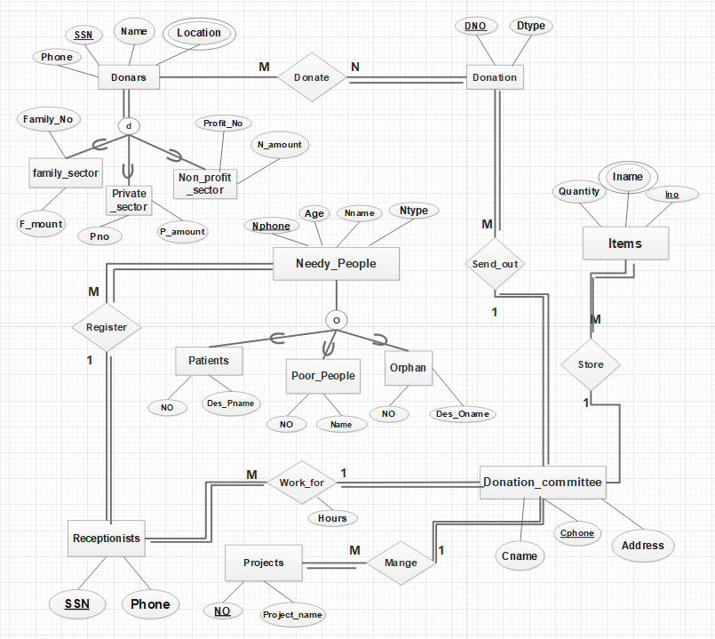

# RELATIONAL MODEL :

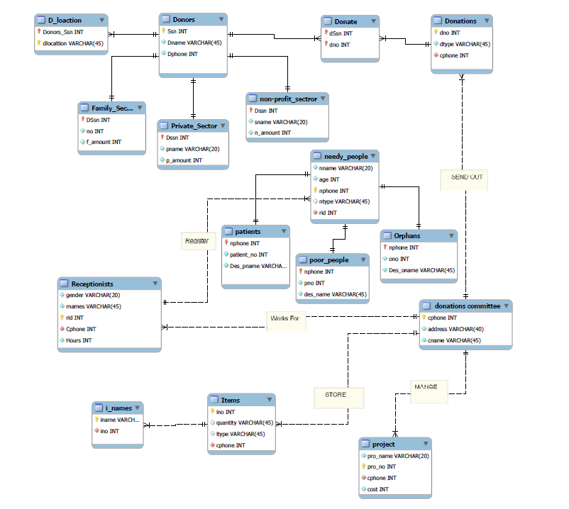

The following queries in SQL on the DONATIONS relational database

1) Retrieve names of and phones of all donors.

Select Dname , Dphone

From donors;

2) Sort needy people according to their ages.

Select nname,age

From needy_people

Order by age desc;

3) Retrieve name of each donor and his donation type .

Select n.Dname , t.dtype

From donors n , donations t ,donate c

Where t.dno=c.dno and

n.ssn=c.dssn;

4) Delete all donors with last name is Bassem.

Delete From donors  
where Dname='Bassem';

5) Retrieve name and cost of each project according to the cost.

select pro_name ,cost

from project

order by cost;

6) For the the dontoion ='clothes' , Retrieve names donor that donate it.

Select n.Dname

from donors n join donate c

on n.ssn=c.dssn

join donations t on t.dno=c.dno

where t.dtype="clothes";

7) Retrieve names of needy people the register with receptionist whose name='mohamed'.

Select p.nname

From needy_people p natural join receptionists s

Where s.rnames='mohamed';

8) list the count of donors of each donation type.

Select count(e.dname) as Donor_name

,t.dtype as Donation_type

From donors e join donate c on e.ssn=c.dssn

join donations t on t.dno=c.dno

Group by t.dtype;

9) Retrieve name , phone of patients or poor people.

select nname, age, ntype

from needy_people natural join orphans

union

Select nname , age , ntype

from needy_people natural join patients;

10) Retrieve the name, ssn and donation type of each donor either donates food or not.

select d.dname,d.ssn,t.dtype

from (donors d left outer join donate c on d.ssn=c.dssn)

natural join donations t

Where t.dtype='food';

11) Retrieve name of each donors who the same (donation type)

Combination on some donation type that donor 'Nader' (whose ssn=' 998754654 ') donates.

Select d.dname ,t.dtype

From donors d join donate c on d.ssn=c.dssn

join donations t on t.dno=c.dno

where (dtype) in(

select dtype

from donors d join donate c on d.ssn=c.dssn

join donations t on t.dno=c.dno

where d.ssn=998754654);

12) Retrieve each poor people who needy type the same donation type

That donors donates.

select nname

from needy_people natural join poor_people

where ntype in(

select t.dtype

from donors n join donate c

on n.ssn=c.dssn

join donations t on t.dno=c.dno

);

13) For each item retrieve whose name and quantity and names of donors that donate the same item.

select i.itype,i.quantity, d.dname

from items i ,donors d,donations t ,donate c

where d.ssn=c.dssn and t.dno=c.dno

and i.itype=t.dtype;

14) Make report that display all items information that the committee include.

Select ino,itype ,quantity,iname

from items natural join i_names

15) Retrieve name of needy people that need='money'

And the their destination and the receptionist that communicate with them.

select nname ,des_oname ,rnames

from (needy_people natural join orphans)natural join receptionists

where ntype='money'

union

select nname ,des_name ,rnames

from (needy_people natural join poor_people)natural join receptionists

where ntype='money';